Visual Studio Code (VSC)

1 - Access https://code.visualstudio.com/
2 - Download VSC
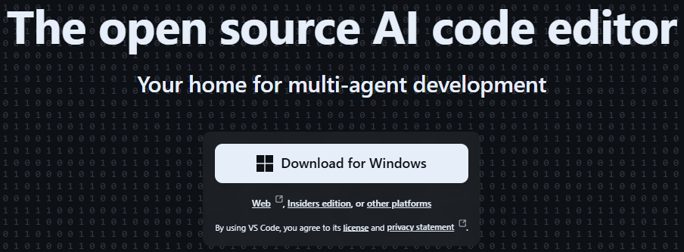
3 - Install VSC (Just keep clicking the “Next” button until the installation finishes)
4 - Open VSC
5 - Click the “Extensions” button on the left side
6 - Install the “Playwright Test for VSCode” plugin
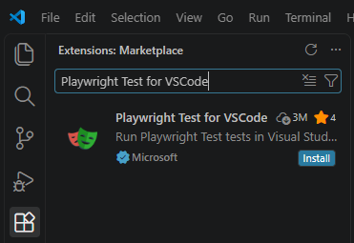
7 - (Optional) Click the “File” tab on the top left side and enable the “Auto Save” option
8 - Close VSC
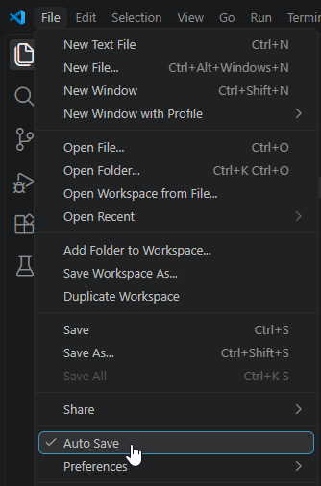

GitHub Desktop

1 - Access https://desktop.github.com/download/
2 - Download GitHub Desktop
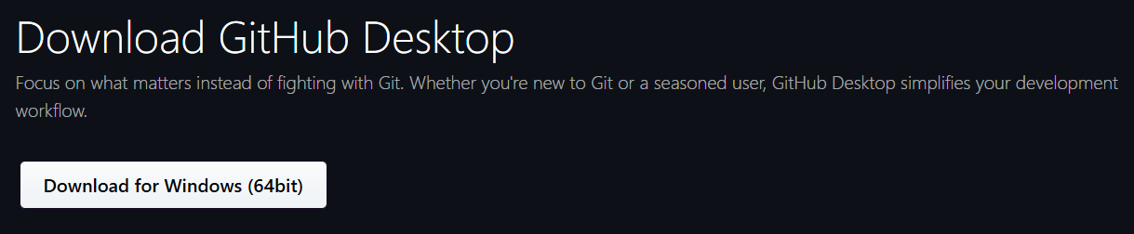
3 - Install GitHub Desktop
4 - Inside the “Welcome to GitHub Desktop” window:
- If you have an account on GitHub: Connect with it
- If you don’t have an account on GitHub: Click on the “Skip this step” button
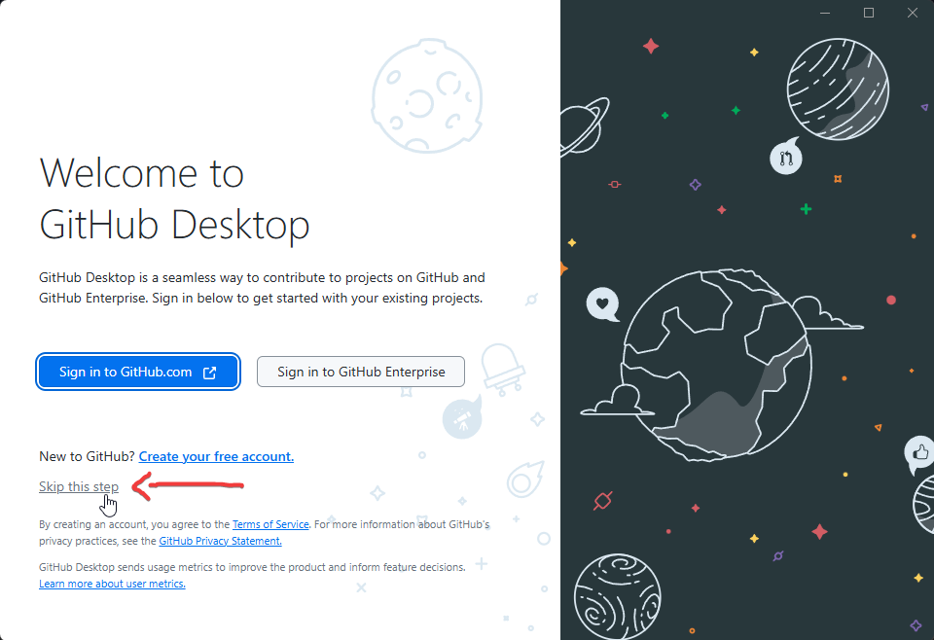
5 - Click the “Clone repository” option
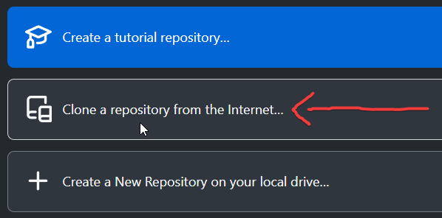
6 - Access https://github.com/alessandro-lafarciola/Playwright-DemoQA
7 - Click the “Code” button
8 - Copy the HTTPS URL
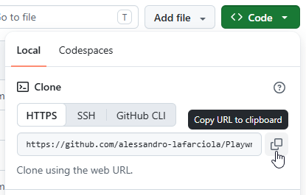
9 - Return to GitHub Desktop and click the “URL” tab
10 - Paste the HTTPS URL
11 - Click the “Clone” button
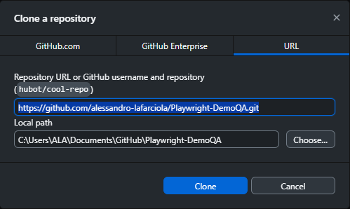
12 - Click the “Fetch origin” button
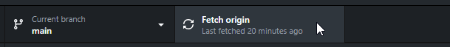

Playwright

1 - Access https://nodejs.org/en/download
2 - Download Node.js
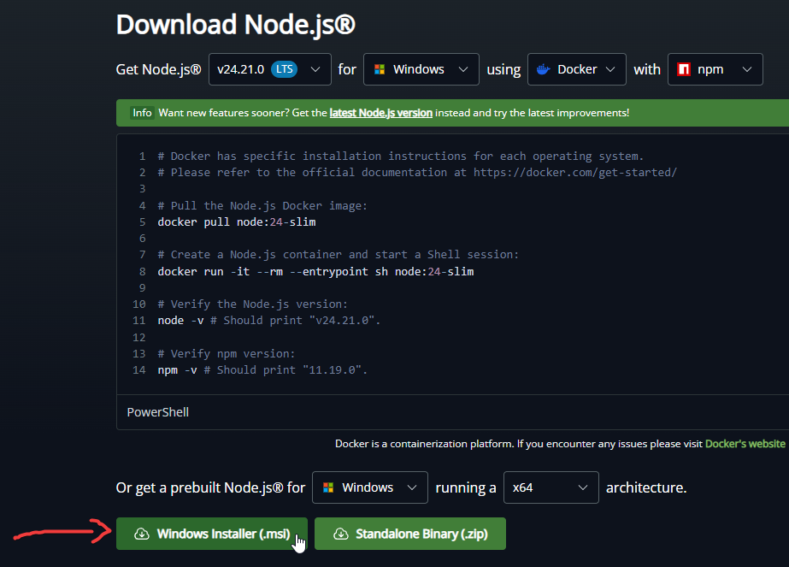
3 - Install Node.js (Just keep clicking the “Next” button until the installation finishes)
4 - Return to GitHub Desktop and right click the repository name on the top left side
5 - Click the “Open in Visual Studio Code” option
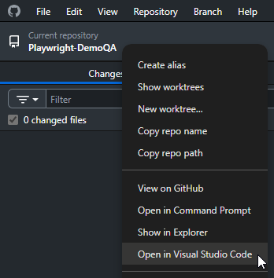
6 - Click the “Terminal” tab on the top left side
7 - Click the “New Terminal” option
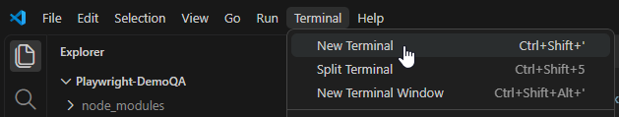
8 - Write the following command in the terminal and press ENTER:
npm ci
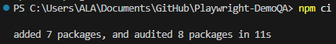
9 - Write the following command in the terminal and press ENTER:
npm install playwright chromium
10 - Write the following command in the terminal and press ENTER:
npm test
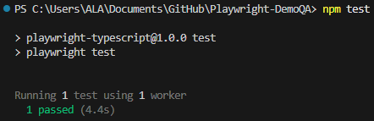
If you see the test passed message, your Playwright installation is complete!

